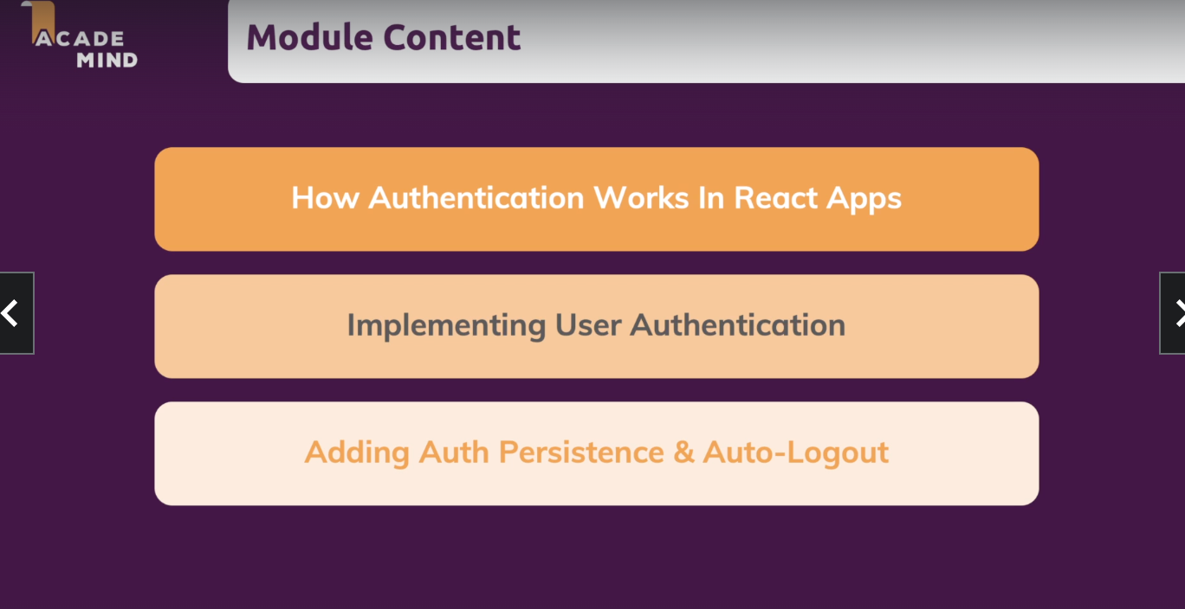

Authentication is needed if content should be protected. Sometimes it can be pages which we dont want users to have access to .

We can use firebase Auth REST API as a dummy backend.

Integrate login and sign up API calls to the application.

We can either use redux or context API for managing the state of the user if the user has logged in or not. In this example we will use react context.

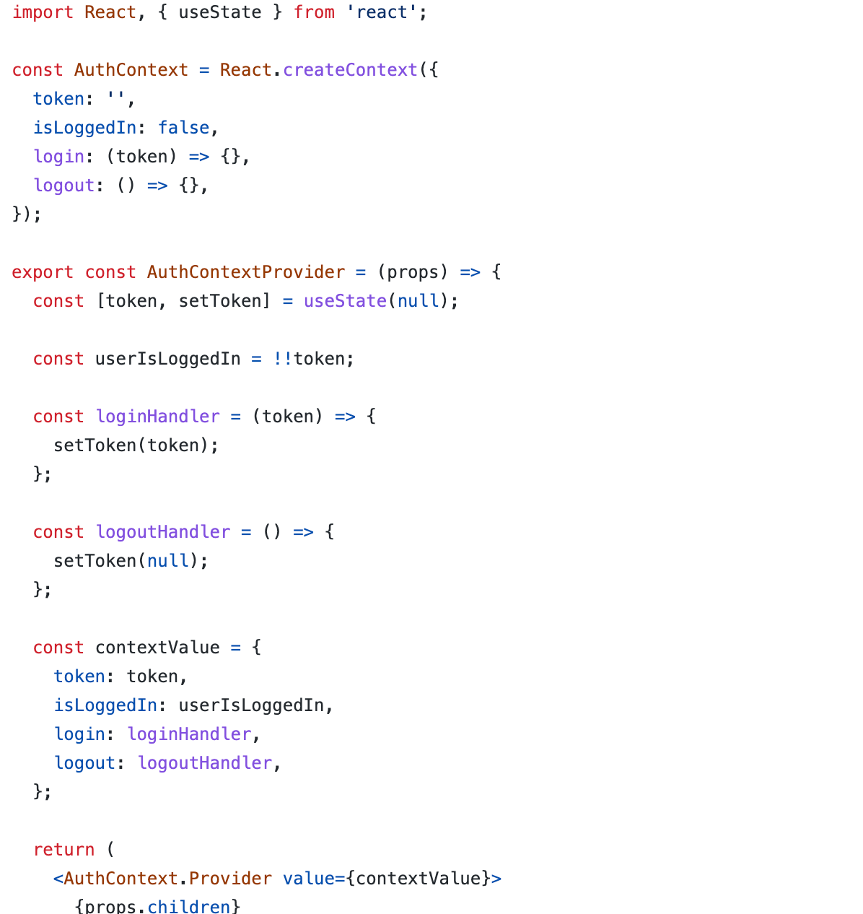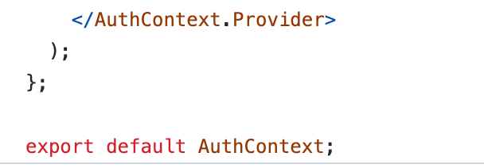

Now we can access this isLoggedin State to check if the user is logged on or not and conditionally render the UI components based on the state.

How to protect API endpoints in React?

Navigation guards and protecting pages in Front -End react.

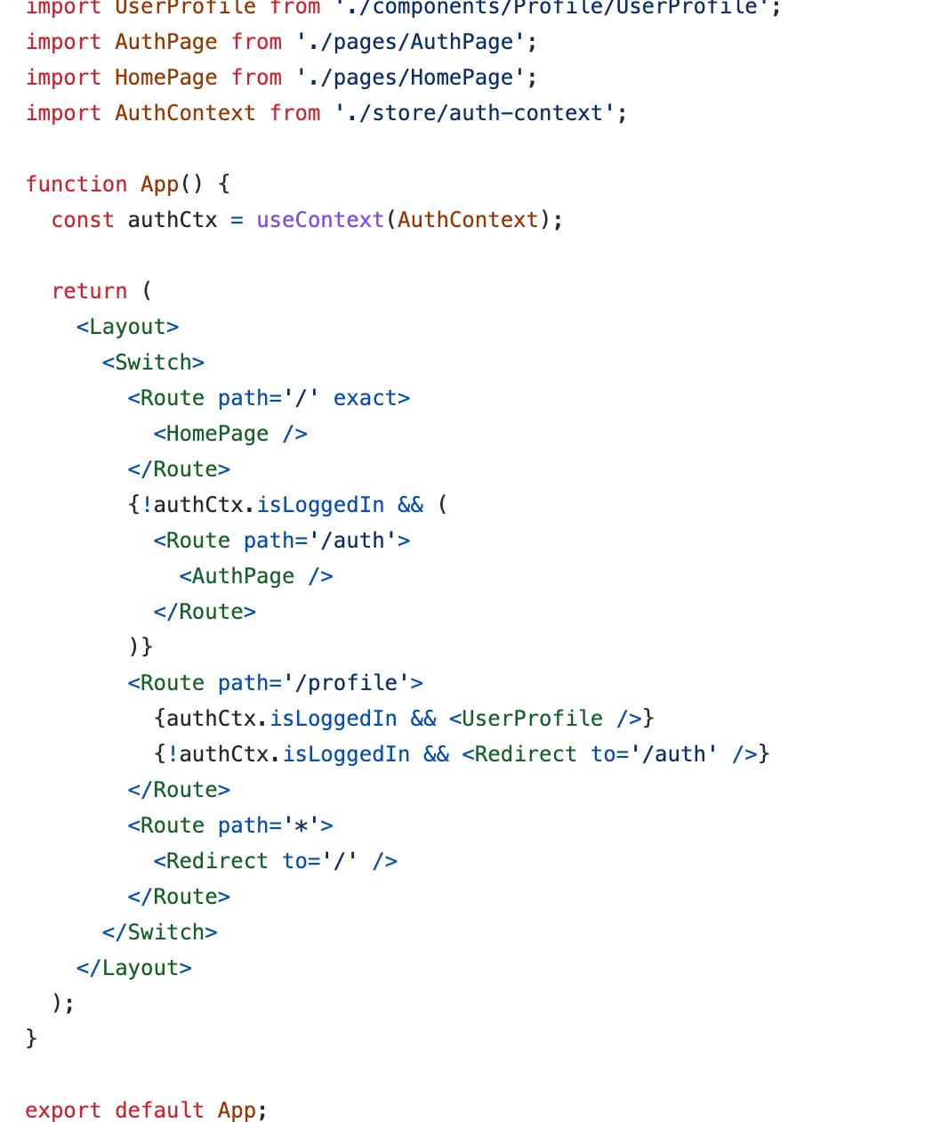

How to persist the user authentication status. (Because whenever we refresh the page the status is lost). We can definitely use localStorage in this case to store the mechanism.

How to automatically log out user ? Adding auto logout feature.

View this code for auto logout feature:-

https://github.com/academind/react-complete-guide-code/blob/22-authentication/code/09-finished/src/store/auth-context.js